Lab 3.1 — Building a Specialized AI Front-End with Streamlit in Snowflake

Table of Contents
Table of Contents 2
Introduction 3
Learning Objectives 3
Prerequisites 3
Part 1 — Provisioning the Enterprise Metadata 4
Step 1 — Create the Metadata Table 4
Step 2 — Insert Technical Definitions 5
Part 2 — Initializing the Streamlit Application 8
Step 1 — Create the Streamlit App 8
Part 3 — Building the AI Front-End 9
Step 1 — Write the Streamlit Code 9
Part 4 — Testing the Prototype 10
Step 1 — Execute the App 10
Step 2 — Observe the Results 13
Knowledge Check 14
Troubleshooting 15
Symptom: snowflake.snowpark.exceptions.SnowparkSQLException: SQL compilation error: Unknown function SNOWFLAKE.CORTEX.COMPLETE 15
Symptom: The UI resets or goes blank when interacting with other elements. 15
Conclusion 15

Introduction
While traditional Business Intelligence platforms excel at standard reporting, they often lack the flexibility required to build highly customized, interactive AI applications. For instance, when business users encounter a complex dashboard metric, they typically have to search through a disconnected wiki or ping a data engineer to understand how it is calculated.
In this lab, you will use Streamlit in Snowflake (SiS) to build a specialized AI front-end: an "AI Metric Explainer." This custom application will allow users to select a highly technical business metric and use Snowflake Cortex to dynamically generate a plain-English explanation, complete with a simulated business example. You will learn how to bridge raw database tables, Snowpark Python, and Large Language Models into a single, cohesive web application hosted entirely within your data platform.

Learning Objectives
Upon completing this lab, you will be able to:
- Provision an underlying metadata layer to support AI-driven data dictionaries.
- Deploy a native Streamlit application directly within Snowflake using Workspaces.
- Utilize the Snowpark Python API to interact with database objects natively.
- Invoke Snowflake Cortex AI functions directly from a Python-based Streamlit interface.

Prerequisites
Before starting, ensure you have:
- Snowflake Enterprise Account with Streamlit in Snowflake (SiS) and Snowflake Cortex enabled.
- SYSADMIN or equivalent privileges to create databases, tables, and Streamlit applications.
- Familiarity with basic Python syntax.

Part 1 — Provisioning the Enterprise Metadata
Before we build the front-end, we need to establish our ground truth. We will create a small metadata table containing highly technical definitions of business metrics.

Step 1 — Create the Metadata Table
Open a Snowsight SQL worksheet and execute the following commands to create the database, schema, and table.
CREATE DATABASE IF NOT EXISTS ai_prototyping;
CREATE SCHEMA IF NOT EXISTS ai_prototyping.metrics;

USE DATABASE ai_prototyping;
USE SCHEMA metrics;

CREATE TABLE metric_definitions (
metric_name VARCHAR,
technical_definition VARCHAR
);
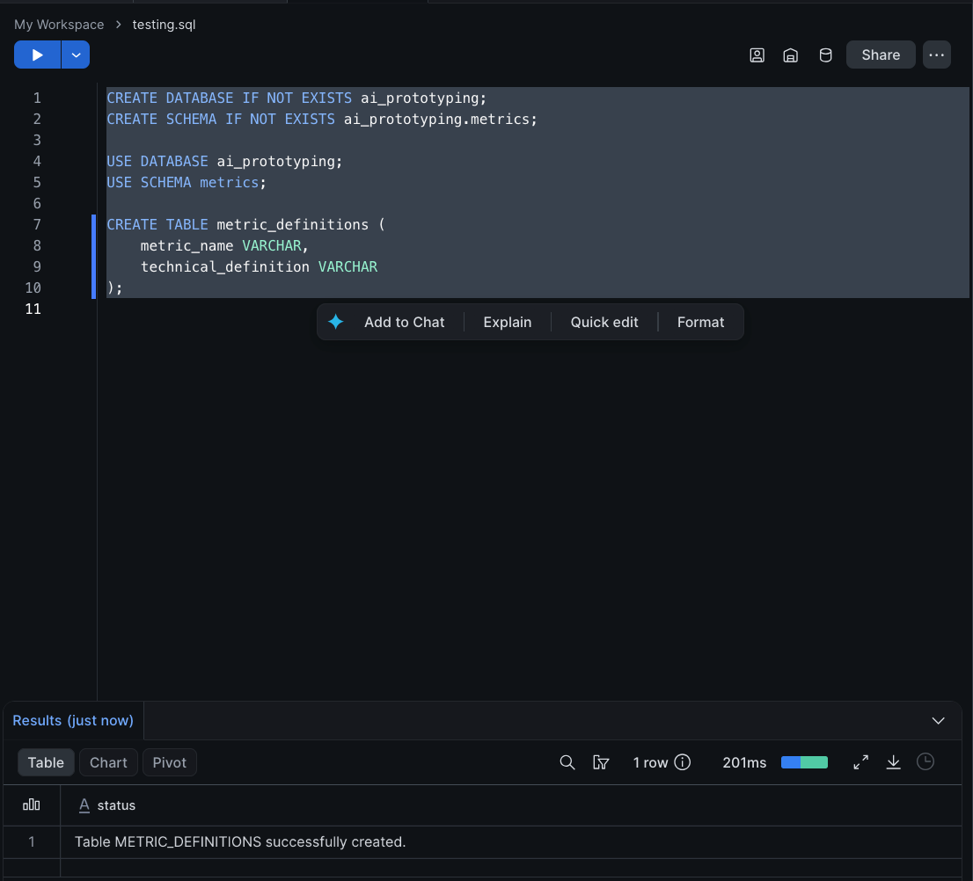

Step 2 — Insert Technical Definitions
Insert sample data representing complex metrics that a standard business user might struggle to interpret.
INSERT INTO metric_definitions (metric_name, technical_definition)
VALUES
('Net Revenue Retention (NRR)', 'SUM(Starting ARR + Expansion ARR - Downgrade ARR - Churn ARR) / SUM(Starting ARR) over a trailing 12-month period.'),
('Customer Acquisition Cost (CAC)', 'Total Sales and Marketing spend (inclusive of overhead, ad spend, and headcount) divided by the total number of new net-logos acquired in the given fiscal quarter.'),
('Monthly Active Users (MAU)', 'Distinct count of user_id from the login_events table where event_type = "session_start" grouped by month(event_timestamp).');
Expected Output: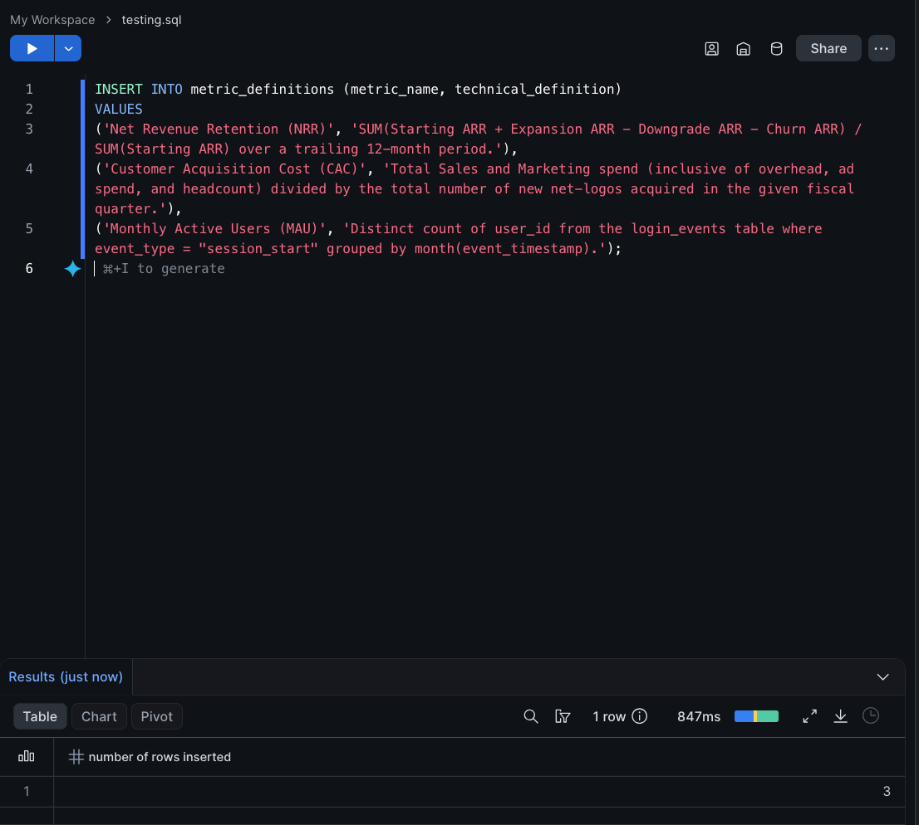

Part 2 — Initializing the Streamlit Application
We will now create the interactive application natively within Snowflake.

Step 1 — Create the Streamlit App
- Navigate to Workspaces > My Workspace on the left-hand menu in Snowflake Snowsight.
- Click the + Add new button and select Streamlit App from the dropdown.
- Name the app AI_Metric_Explainer and press Enter.
- Snowflake will immediately open a dual-pane view: a Python code editor on the left containing boilerplate code, and a live app preview on the right.
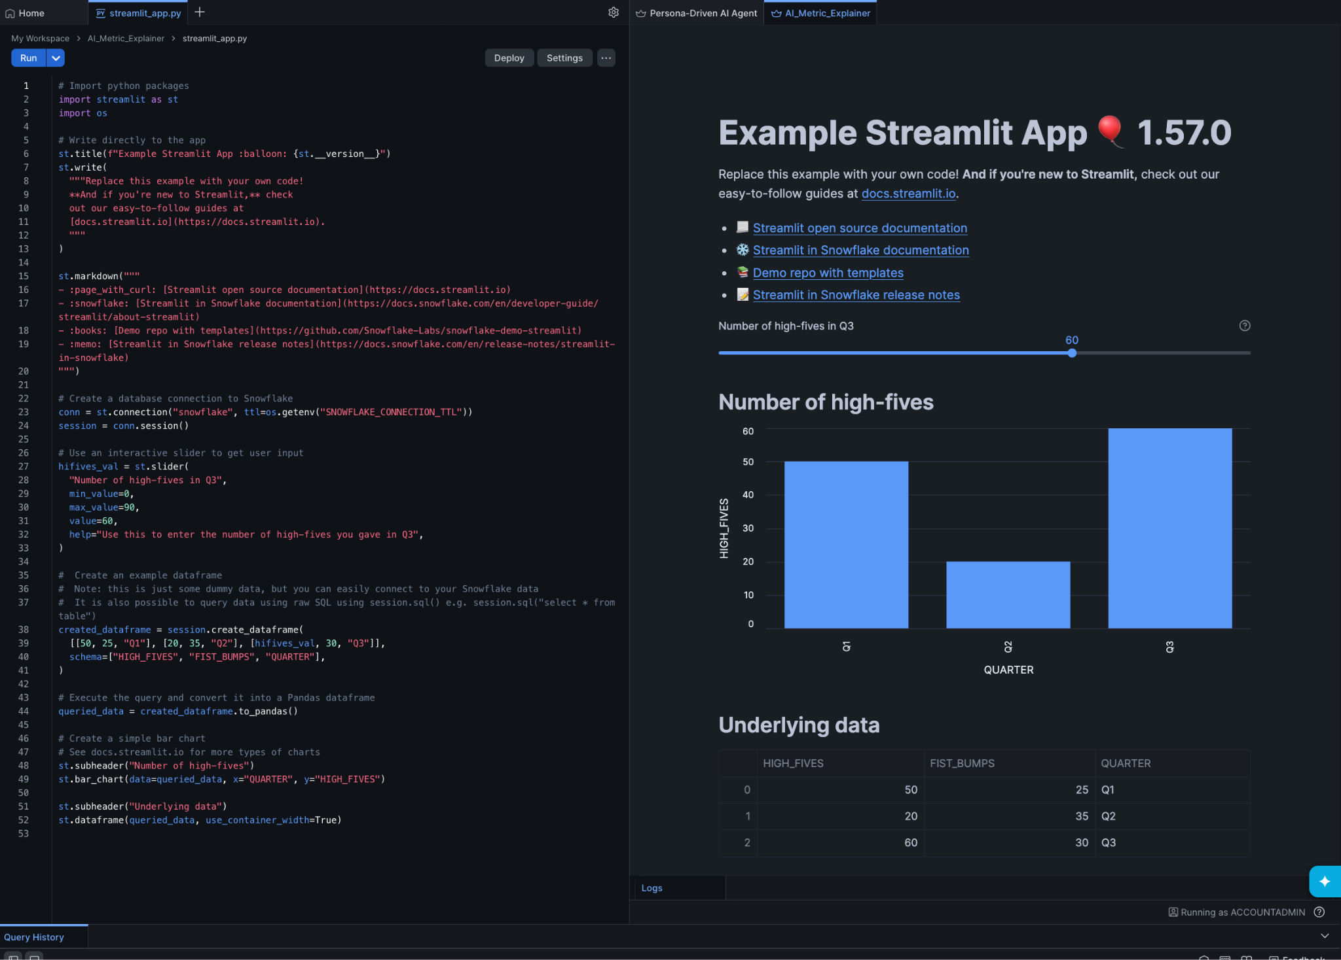

Part 3 — Building the AI Front-End
We will replace the boilerplate code with a Python script that provides a dropdown for the user to select a metric, fetches the technical definition, and uses Cortex to translate it.

Step 1 — Write the Streamlit Code
Replace all the default code in the left-hand editor with the following script.
import streamlit as st
from snowflake.snowpark.context import get_active_session

# Configure the Streamlit page layout
st.set_page_config(layout="centered", page_title="AI Metric Explainer")
st.title(" AI Metric Explainer")
st.write("Select a dashboard metric to get a plain-English explanation generated by AI.")

# Retrieve the active Snowflake session
session = get_active_session()

# Fetch metric names for the dropdown UI
@st.cache_data
def get_metrics():
# Using fully qualified name to ensure the workspace app finds the correct table
df = session.table("ai_prototyping.metrics.metric_definitions").to_pandas()
return df

metrics_df = get_metrics()

# Create the dropdown selection UI
selected_metric = st.selectbox("Choose a Metric:", metrics_df['METRIC_NAME'].tolist())

# Create a button to trigger the AI generation
if st.button("Explain this Metric", type="primary"):

# 1. Look up the technical definition
tech_def = metrics_df[metrics_df['METRIC_NAME'] == selected_metric]['TECHNICAL_DEFINITION'].iloc[0]

# Show the user the raw technical logic
st.subheader("Technical Definition (Data Engineering)")
st.code(tech_def, language='sql')

# 2. Construct the prompt for Snowflake Cortex
prompt = f"""
You are an expert Business Intelligence Coach.
Translate the following highly technical metric definition into a simple,
easy-to-understand explanation for a non-technical executive.
Provide one real-world, simple example with hypothetical numbers to illustrate it.

Metric Name: {selected_metric}
Technical Definition: {tech_def}
"""

# 3. Call Snowflake Cortex via Snowpark SQL execution
with st.spinner('Generating AI Explanation...'):
# We use session.sql to dynamically execute the CORTEX.COMPLETE function
query = f"SELECT SNOWFLAKE.CORTEX.COMPLETE('llama3-8b', '{prompt}') AS AI_RESPONSE"
cortex_result = session.sql(query).collect()

ai_response_text = cortex_result[0]['AI_RESPONSE']

# Display the output
st.subheader("AI Explanation (Business Executive)")
st.markdown(ai_response_text)

Part 4 — Testing the Prototype
It is time to interact with the specialized AI front-end you just built.

Step 1 — Execute the App
- Click the Run button in the top left corner of the code editor.
- In the right-hand preview panel, select Net Revenue Retention (NRR) from the dropdown list.
- Click the Explain this Metric button.
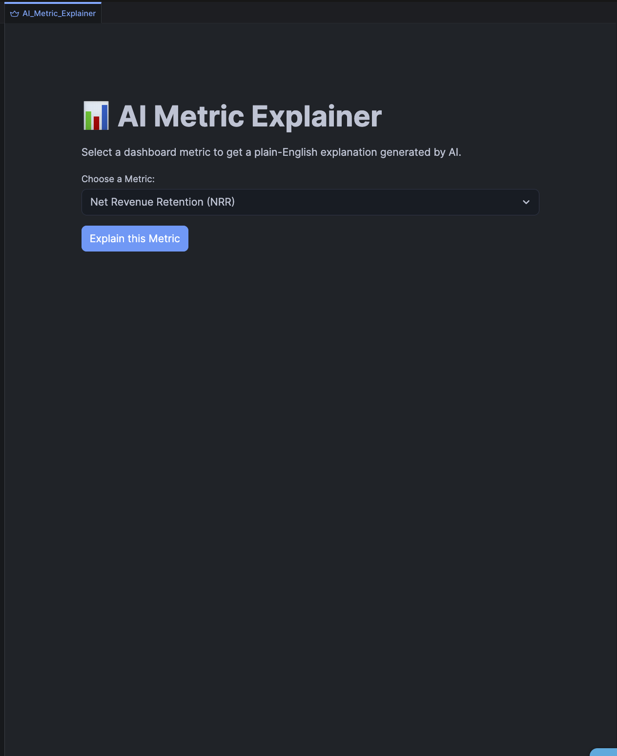


Step 2 — Observe the Results
You should see two distinct sections appear:
- The raw, technical definition pulled instantly from the Snowflake table.
- A dynamically generated Markdown response from the llama3-8b model explaining the metric in plain English and providing a hypothetical mathematical example.
Try selecting the other metrics to observe how the AI dynamically adapts to different technical concepts.

Knowledge Check
- Why do we use @st.cache_data above the get_metrics() function?
  - Answer: It prevents the Streamlit app from querying the database for the list of metrics every single time the user interacts with the app (e.g., clicking a button), significantly improving front-end performance and reducing warehouse compute costs.
- How does the application communicate with Snowflake Cortex?
  - Answer: The application utilizes the Snowpark session.sql() method to construct and execute a standard SQL query containing the SNOWFLAKE.CORTEX.COMPLETE function, pulling the response back into Python using .collect().

Troubleshooting

Symptom: snowflake.snowpark.exceptions.SnowparkSQLException: SQL compilation error: Unknown function SNOWFLAKE.CORTEX.COMPLETE
Solution: The role executing the Streamlit app does not have access to Cortex functions, or your Snowflake account is in a region that does not yet support Cortex. Ensure your role is granted the CORTEX_USER database role (GRANT DATABASE ROLE SNOWFLAKE.CORTEX_USER TO ROLE your_role;).

Symptom: The UI resets or goes blank when interacting with other elements.
Solution: Streamlit reruns the entire Python script from top to bottom every time a user interacts with a widget (like a button or dropdown). If an element is nested inside an if st.button(): block, it will disappear on the next interaction unless you implement Session State (which we will cover in the next lab).

Conclusion
In this lab, you successfully built a specialized, AI-powered Business Intelligence front-end. By leveraging Streamlit in Snowflake, you deployed a fully functional web application that securely queries enterprise metadata via Snowpark and translates complex logic into digestible insights using Snowflake Cortex. This architecture allows data teams to rapidly prototype and deploy targeted AI tools directly adjacent to the data, bypassing the limitations of rigid, read-only dashboards.

